DBS311E Lab 4 – E-Mail submission only, your document must have both SELECT statements and the OUTPUTS.

Subject of your mail must be like 311-Lab4 by Smith, John

Due by Thursday, June 24th^{th} by 9pm

Questions 1 and 2 use DEMO (HR) schema, while questions 3 to 6 use PRODUCT schema

- The HR department needs a list of Department IDs for departments that do not contain the job ID of ST_CLERK. Exclude NULL departments from your result. Use a set operator to create this list.
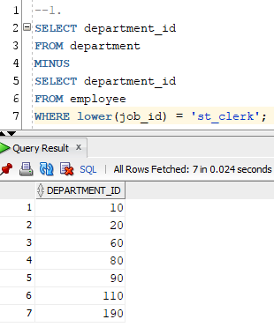
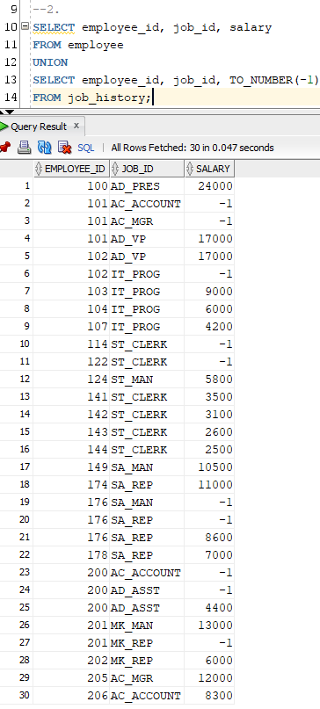
- Display list with employee’s Id, Job Id and Salary that will include the current job and salary and all previous Jobs , if they have them (here you will display salary of -1). Use a set operator for this report.
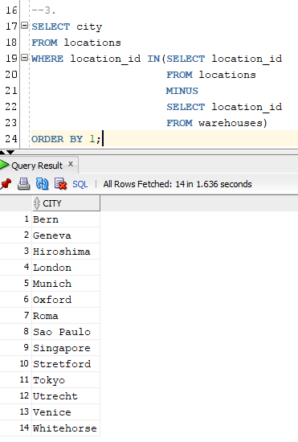
- Display cities that no warehouse is located in them. Use set operator to answer this question.

- Display the category ID, category name, and the number of products in category 1, 2, and 5. In your result, display first the number of products in category 5, then category 1 and then 2.
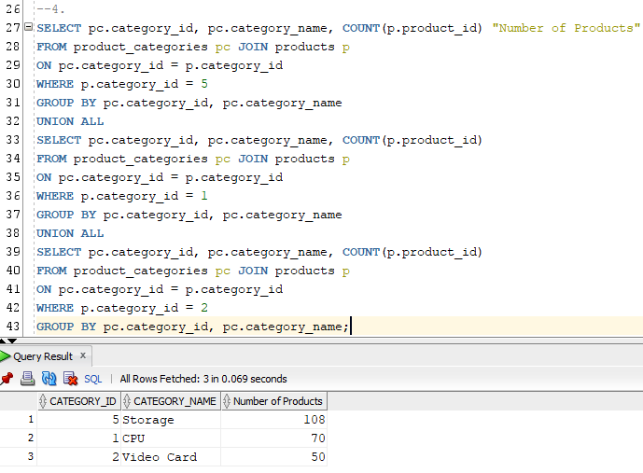
Use ANY method to solve this problem.

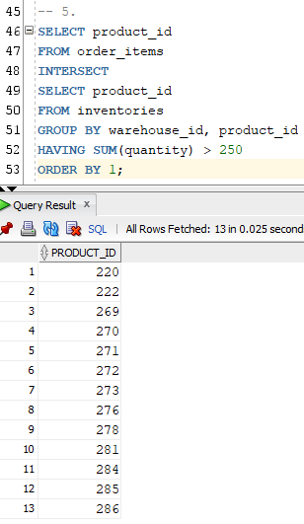
- Display product ID for ordered products whose quantity in the inventory is greater than 250. (You are not allowed to use JOIN for this question.)

- We need a single report to display all warehouses and the city and state that they are located in, also all states regardless of whether they have warehouses in them or not.
If state value is blank, display No State.
Here is a partial output:
Loc# City State Warehouse
------- -------------------- ----------------- -----------------
1 Roma No State
2 Venice No State
3 Tokyo Tokyo Prefecture
4 Hiroshima No State
5 Southlake Texas
5 Southlake, Texas
6 South San Francisco California
6 San Francisco

